Turboelectric Propulsion
Worksheet CW1

Abhinandan Thour
32453515
Meng Mechanical & Aerospace Engineering
University of Southampton
2023-2024

The coursework commences with the definition of the provided data for the aircraft, resembling the configuration of STARC-ABL as elucidated by Welstead and Felder in their 2016 study.
Figure 1 - STARC-ABL isometric view. Key features include the rear fuselage BLI fan, the T-tail empennage, and the reduced size turbofans allowed by the turboelectric propulsion system (Welstead and Felder, 2016).

Assumptions were made during the analysis of aircraft, air and combustion products were treated as flows of perfect gases with properties given in Table 1. The addition of fuel mass was neglected, all nozzles were assumed fully expanded, and any pressure drop in intakes or ducts were neglected.

Cruise | Mach 0.7 at 35,000 ft, International Standard Atmosphere
Fan | Pressure ratio: 1.45; Isentropic efficiency 94%
LPC | Pressure ratio: 1.45; Isentropic efficiency 92%
HPC | Pressure ratio: 27.9; Isentropic efficiency 92%
HPT | Isentropic efficiency: 92%
LPT | Isentropic efficiency: 94%
Tail cone Fan | Pressure ratio: 1.25; Isentropic efficiency 96%
Overall electrical efficiency | 90%
T₀₄ | 1540 K
Air properties | c_{p}: 1005 J.kg⁻¹.K⁻¹; c_{p}/c_{v} = 1.4
Combustion products | c_{p}: 1100 J.kg⁻¹.K⁻¹; c_{p}/c_{v} = 1.3
Number of fan-generators | $n_{FG}=$2
Overall Bypass Ratio | $({n_{FG}×\dot{m}}_{Bypass}+{\dot{m}}_{TCF})/(n_{FG}×{\dot{m}}_{Core})=14.4$
Fan-Gen Bypass Ratio | ${\dot{m}}_{Bypass}/{\dot{m}}_{Core}=6.4$
$R_{1}$ | 0.35 m
$R_{2}$ | 1.0 m
Pressure loss in combustor | 5% of stagnation pressure
Boundary layer thickness | $δ$: 1.0 m
Table 1 - Parameters for coursework analysis

4.1.
Flight velocity | $$V_{∞}= 207.5519 m/s^{2}$$
Fan inlet | $$T_{02}=240.2424 K$$ | $$P_{02}=33.0130 KPa$$
Fan outlet | $$T_{013}=268.8672 K$$ | $$P_{013}=47.8689 KPa$$
LPC outlet | $$T_{023}=299.5232 K$$ | $$P_{023}=69.4098 KPa$$
HPC outlet | $$T_{03}=816.6535 K$$ | $$P_{03}=1936.5350 KPa$$
HPT outlet | $$T_{045}=1067.5310 K$$ | $$P_{045}=317.1638 KPa$$
Bypass jet velocity | $$V_{jB}=312.7424 m/s^{2}$$
Table 2 - 4.1 Table for the fanGen
As presented in Table 2, the calculation of the aircraft's flight velocity is the initial step, given its necessity for subsequent calculations.
To determine $V_{∞}$, it is necessary to obtain both $M_{∞}$ and $a_{∞}$. The former is provided in Table 1, while the latter can be computed based on atmospheric conditions.
$$T_{35, 000ft}=218.8 K$$
$$P_{35, 000ft}=23.8 KPa$$
Thus:
$$V_{∞}=\frac{M_{∞}}{\sqrt{γ_{air}*R_{air}*T_{35, 000ft}} }$$
$V_{∞}=\frac{0.7}{\sqrt{1.4*287*218.8} }= 207.5519 m/s^{2}$

For a more comprehensive understanding of the engine's design, an engine layout and station numbering schematic has been designed to visualize the distribution of various properties:
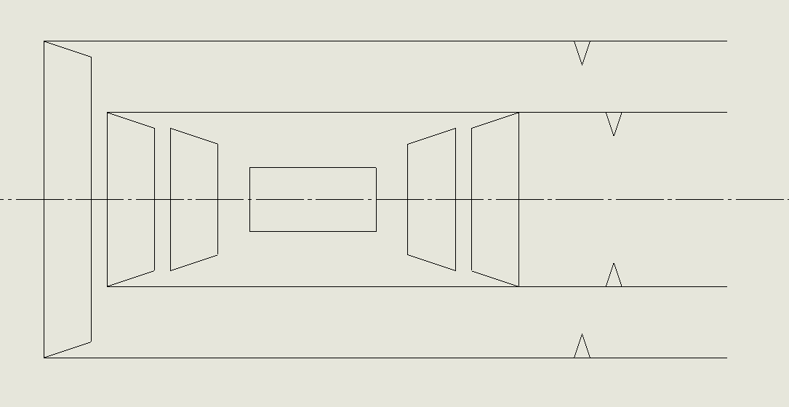
Figure 3 - Engine Layout and Station Numbering

We follow a procedural approach to compute the fan inlet conditions $T_{02}$ and $P_{02}$:
$$T_{02}= T_{35, 000ft}*\left(1+\frac{γ_{air}-1}{2}*M_{∞}^{2}\right)= 218.8*\left(1+\frac{1.4-1}{2}*{0.7}^{2}\right)= 240.2424 K \\ P_{02}= P_{35, 000ft}*{\left(\frac{T_{02}}{T_{35, 000ft }}\right)}^{\frac{γ_{air}}{γ_{air}-1}}=23.8*{\left(\frac{240.2424}{218.8}\right)}^{\frac{1.4}{1.4-1}}= 33.0130 KPa$$

With the aforementioned conditions in place, we proceed to calculate the exit conditions of the fan, $T_{013}$ and $P_{013}$:
The temperature ratio across the fan is:
$$\frac{T_{013}}{T_{02}}=1+\frac{{pr}_{fan}^{\frac{γ_{air-1}}{γ_{air}}}-1}{η_{fan}}$$
Arranging the formula for${ T}_{013}$:
$$T_{013}= T_{02}+\frac{T_{02}}{η_{fan}}*\left({pr}_{fan}^{\frac{γ_{air-1}}{γ_{air}}}-1\right)= 240.2424 +\frac{240.2424 }{0.94}*\left({1.45}^{\frac{1.4-1}{1.4}}-1\right)= 268.8672 K$$
$$P_{013}= P_{02}*{pr}_{fan}= 33.0130*1.45= 47.8688 KPa$$

Upon obtaining the outlet values of the fan, we can now proceed to calculate the exit parameters $T_{023}$ and $P_{023}$ of the LPC. It is worth noting that the outlet temperature and pressure of the fan pass through the LPC individually, as they are not interconnected. In this context, we introduce a new variable, ${pr}_{booster}$ , which serves to define the pressure ratio between the fan inlet and the LPC outlet.
$${pr}_{booster}= {pr}_{fan}* {pr}_{LPC}$$
As, the temperatures resulting from isentropic compression and expansions can be evaluated using the following relation for isentropic processes in perfect gases, ${P/T}^{\frac{γ_{air-1}}{γ_{air}}}$ which leads to $\frac{T_{023s}}{T_{02}}={\left(\frac{P_{03}}{P_{35000ft}}\right)}^{\frac{γ_{air-1}}{γ_{air}}}$, therefore:
$$T_{023s}={pr}_{booster}^{\frac{γ_{air-1}}{γ_{air}}}*T_{02}={\left(1.45*1.45\right)}^{\frac{1.4-1}{1.4}}*240.2424=297.0707 K$$
$$T_{023}={(T}_{023s}-T_{013})/η_{LPC}+T_{02}=(297.0707- 268.8672)/0.92+240.2424=299.5232 K$$
$$P_{03}= P_{02}*{pr}_{booster}=33.0130* \left(1.45*1.45\right)=69.4098 KPa$$

Subsequently, the outlet of the HPC, $T_{03}$ and $P_{03}$:
$$T_{03s}={pr}_{HPC}^{\frac{γ_{air-1}}{γ_{air}}}*T_{023}={27.9}^{\frac{1.4-1}{1.4}}*299.5232=775.2831 K$$
$$T_{03}={(T}_{03s}-T_{023})/η_{HPC}+T_{023}=(775.2831- 299.5232)/0.92+299.5232=816.6535 K$$
$$P_{03}= P_{023}*{pr}_{HPC}=69.4098* 27.9=1936.5350 kPa$$

During the combustion process, there is a Pressure drop of 5% therefore the outlet pressure is 95% of the inlet pressure, as follows:
$$P_{04}=P_{03}*\left(1-Pressure loss\right)= 1936.5350*0.95= 1839.7082 kPa$$
To determine the $T_{045}$ ,we apply the following condition by equating the inlet and outlet enthalpy conditions of the combustor.
$$m_{air}*C_{p, air}*\left(T_{03}-T_{023}\right)= {(m}_{air}+m_{fuel})*C_{p, product}*\left(T_{04}-T_{045}\right)$$
Since $m_{air}≫m_{fuel}$, we can simplify the equation by disregarding $m_{fuel}$, resulting in:
$$T_{045}= T_{04}-\frac{C_{p, air}}{C_{p, comb}}*\left(T_{03}-T_{023}\right)=1540-\frac{1005}{1100}*\left(816.6535-299.5232 \right)=1067.5310 K$$

To determine the outlet $P_{045}$, $T_{045s}$ is required:
$$T_{045s}= T_{04}-\frac{T_{04}- T_{045}}{η_{HPT}}=1540-\frac{1540-1067.5310}{0.92}= 1026.4466 K$$
$$P_{045}= P_{04}*{\left(\frac{T_{045s}}{T_{04 }}\right)}^{\frac{γ_{comb-1}}{γ_{comb}}}= 1839.7082 *{\left(\frac{1067.5310}{1540}\right)}^{\frac{1.3-1}{1.3}}= 317.1637 kPa$$

Following the table, $V_{jB}$, the velocity in the bypass is to be calculated:
$$V_{jB}= \sqrt{2*C_{p, air}*T_{013}*\left(1-{\left(\frac{P_{35, 000ft}}{P_{013}}\right)}^{\frac{γ_{air-1}}{γ_{air}}}\right)}=\sqrt{2*1005*268.8672*\left(1-{\left(\frac{23.8}{47.8688}\right)}^{\frac{1.4-1}{1.4}}\right)}=312.7424 m/s^{2}$$
4.2:
Inlet static state | $T_{BLI}=224.5486 K$ | $P_{BLI}= 23.8 kPa$
Inlet velocity and area | $V_{BLI}=178.2001 m/s^{2}$ | $A_{in}= 2.7567 m^{2}$
Density and mass flow | $ρ_{BLI}=0.3690 kg/m^{2}$ | ${\dot{m}}_{TCF}=181.4219 kg/s$
Inlet stagnation state | $T_{02,TCF}=240.3550 K$ | $P_{02, TCF}= 30.1979 kPa$
Tail Cone Fan outlet | $T_{013,TCF}=256.8373 K$ | $P_{013,TCF}=37.7474 kPa$
Tail Cone Fan jet velocity | $V_{jTCF}=252.4655 m/s^{2}$
Net thrust (kN) | $F_{N,TCF}=13.4733 kN$
Shaft power (kW) | ${\dot{W}}_{x,TCF}=3005.1903 kW$
Propulsive efficiency of tail cone fan | $η_{p,TCF}=58.2918 \%$
Table 3 - 4.2 Table for the Tail Cone Fan

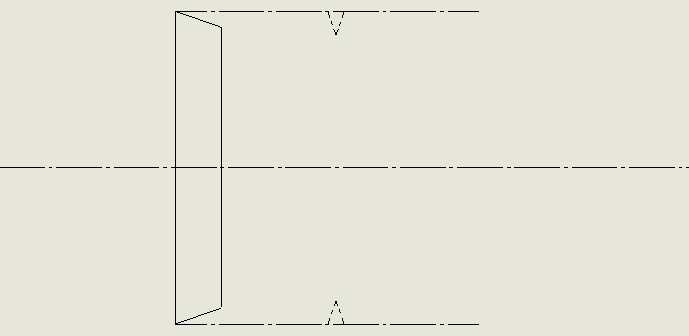
Figure 4 - Tail cone fan Layout and Station Numbering

To calculate $T_{BLI}$ and $P_{BLI}$ The flow through the aircraft boundary layer as adiabatic, implying constant specific stagnation enthalpy, giving, $h_{02,BLI}=h_{02}$ (where stations 2 and 2BLI denote the entries to the genFan and the tail cone fan respectively) which implies:
$$T_{02, BLI}= T_{02}=240.2424 K$$
For the calculation of $T_{BLI}$, we can utilize the inverse formula of the Mach number, $M_{BLI}$. This Mach number can be determined using a Mach number relation provided in the Thermofluid data book, which, in turn, necessitates the value of $V_{BLI}$ :
The formula for $V_{BLI}$ was given in the description of the assignment:
$$V_{BLI}=V_{∞}δ^{-1/7}\frac{\left[\frac{7}{16}{\left(R_{2}-R_{1}\right)}^{\frac{16}{7}}+\frac{7}{9}R_{1}{\left(R_{2}-R_{1}\right)}^{\frac{9}{7}}\right]}{\left[\frac{7}{15}{\left(R_{2}-R_{1}\right)}^{\frac{15}{7}}+\frac{7}{8}R_{1}{\left(R_{2}-R_{1}\right)}^{\frac{8}{7}}\right]}=207.5518*1^{-\frac{1}{7}}\frac{\left[\frac{7}{16}{\left(1-0.35\right)}^{\frac{16}{7}}+\frac{7}{9}0.35{\left(1-0.35\right)}^{\frac{9}{7}}\right]}{\left[\frac{7}{15}{\left(1-0.35\right)}^{\frac{15}{7}}+\frac{7}{8}0.35{\left(1-0.35\right)}^{\frac{8}{7}}\right]}=178.2001 m/s^{2}$$
$$\frac{V_{BLI}}{\sqrt{C_{p, air}*T_{02, BLI}}}=\frac{178.2001}{\sqrt{1005*240.2424}}=0.3626$$
Upon interpolating this value in the data book, we find that $M_{BLI}=0.5933$, resulting in:
$$T_{BLI}=\frac{V_{BLI}^{2}}{M_{BLI}^{2}*γ_{air}*R_{air}}=\frac{{178.2001 }^{2}}{{0.5933}^{2}*1.4*287}= 224.5485 K$$
The pressure in the boundary layer, $P_{BLI}$ is distributed uniformly and assumed to be the equal to Atmospheric pressure, $P_{35, 000ft}$
$$P_{BLI}=P_{35, 000ft}=23.8 kPa$$

Having both inner and outer radius, $R_{1}$ and $R_{2}$, Area, $A_{in}$ is:
$$A_{in}= π*R_{2}^{2}-π*R_{1}^{2}= π*1^{2}-π*{0.35}^{2}= 2.7568 m^{2}$$

Density, $ρ_{BLI}$, can be determined with Equation of State in Ideal Gas Relationship:
$$ρ_{BLI}= \frac{P_{BLI}}{R_{air}*T_{BLI}}=\frac{23.8}{287*224.5485}= 0.3693\frac{kg}{m^{3}}$$

Having, $V_{BLI}$, $A_{in}$ and $ρ_{BLI}$, ${\dot{m}}_{TCF}$ can be determined by the following formula:
$${\dot{m}}_{TCF}=V_{BLI}*A_{in}*ρ_{BLI}= 178.2001*2.7568*0.3693= 181.4219\frac{kg}{s}$$

With the environmental conditions surrounding the Tail Cone Fan, it is now possible to calculate both the inlet and outlet states of this component:
- Inlet Stagnation State:
$$T_{02,TCF}= T_{BLI}*\left(1+\frac{γ_{air}-1}{2}*M_{BLI}^{2}\right)=240.3550 K$$
Or
$$T_{02,TCF}= T_{02, BLI}=240.2424 K$$
$$P_{02, BLI}=P_{BLI}*{\left(1+\frac{γ_{air}-1}{2}*M_{BLI}^{2}\right)}^{\frac{γ_{air}}{γ_{air}-1}}=23.8*{\left(1+\frac{1.4-1}{2}*{0.5933}^{2}\right)}^{\frac{1.4}{1.4-1}}=30.1979 kPa$$
$$P_{02, TCF}=P_{02, BLI}=30.1979 kPa$$
- Tail Cone Fan outlet:
$$T_{013,TCF}= T_{02,TCF}+\frac{T_{02,TCF}}{η_{TCF}}*\left({pr}_{TCF}^{\frac{γ_{air-1}}{γ_{air}}}-1\right)=240.3550+\frac{240.3550 }{0.96}*\left({1.25}^{\frac{1.4-1}{1.4}}-1\right)=256.8373 K$$
$$P_{013,TCF}=P_{02, TCF}*{pr}_{TCF}= 30.1979*1.25= 37.7474 kPa$$

These values allow for the calculation of the Tail Cone Fan jet velocity, $V_{jTCF}$:
$$V_{jTCF}= \sqrt{2*C_{p, air}*T_{013, TCF}*\left(1-{\left(\frac{P_{BLI}}{P_{013, TCF}}\right)}^{\frac{γ_{air-1}}{γ_{air}}}\right)}=\sqrt{2*1005*256.8373*\left(1-{\left(\frac{23.8 }{37.7474}\right)}^{\frac{1.4-1}{1.4}}\right)}=252.4655 m/s^{2}$$

Which can be used to calculate the Net Trust produced by the Tail Cone Fan, $F_{N,TCF}$ which is the Flux of momentum entering the TCF minus the Flux of momentum leaving the TCF:
$$F_{N,TCF}={\dot{m}}_{TCF}*\left(V_{jTCF}-V_{BLI}\right)=181.4219*\left(252.4655-178.2001\right)=134733.687 N$$
$$F_{N,TCF}= 13.4733 kN$$

Shaft Power ${\dot{W}}_{x,TCF}$ can also be computed, as it will be utilized in the calculation of the LPT power, ${\dot{W}}_{xLPT}$, as specified in table 4.5. This can be determined using the Steady-Flow Energy Equation which is an expression of the First Law of Thermodynamics applied to a steady-flow device. ${△h}_{0}$ is the stagnation enthalpy difference between the exhaust flow and the inlet air.
$${\dot{{\dot{Q}}_{net}-W}}_{x,net}={\dot{m}}_{net}*{△h}_{0}$$
As there is there is no addition of heat, ${\dot{Q}}_{net}=0$
$${\dot{W}}_{x,net}={\dot{m}}_{net}*C_{p, air}*\left(T_{013,TCF}- T_{02,TCF}\right)$$
$${\dot{W}}_{x,TCF}={\dot{m}}_{TCF}*C_{p, air}*\left(T_{013,TCF}- T_{02,TCF}\right)=181.4219*1005*\left(256.8373- 240.3550\right)=30051903 W$$
$${\dot{W}}_{x,TCF}=3005.1903 kW$$

Therefore, the Propulsive efficiency of the Tail Cone Fan, $η_{p,TCF}$ can vary due to various factors, including the intake area. Adjusting $R_{2}$can be employed to achieve a particular Propulsive efficiency, as illustrated in the graph in Section 4.3.
$$η_{p,TCF}=\frac{Power to the aircraft}{Power TCF jet}$$
$$η_{p,TCF}=\frac{V_{∞}* {(V}_{jTCF}-V_{∞})}{\frac{1}{2}\left({V_{jTCF}^{2}+V}_{BLI}^{2}\right)}=\frac{207.5518*(252.4655-207.5518)}{\frac{1}{2}\left({252.4655}^{2}* {178.2001}^{2}\right)}=0.5829$$
$$η_{p,TCF}=58.2918\%$$
4.3
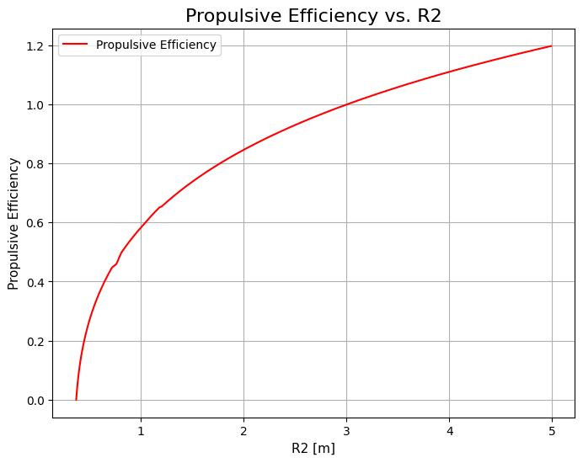
Figure 5 - Propulsive Efficiency change with Outer Radius
4.4
The $η_{p}$ of a jet engine, particularly the tail cone fan in a turbofan engine, is influenced by various factors, with $R_{2}$ playing a central role:
Inlet Velocity and Outlet Velocity Ratio: $η_{p}$ is maximized when the velocities $V_{jTCF}$ and $V_{BLI}$ are equal, increasing the outer radius, $R_{2}$ of the tail cone fan leads to a higher Inlet/Outlet velocity ratio. Thus, a larger $R_{2}$ generally leads to higher efficiency, aligning with the observed trend in the graph. There is a limit to how much $R_{2}$ can increased due to additional weight, impracticality in manufacturing and logistics.
Intake Area: Increasing $R_{2}$ results in a larger intake area, allowing more air to be ingested into the engine. This can enhance overall engine performance and efficiency.
Fan Pressure Ratio: A larger $R_{2}$ tends to reduce the ${pr}_{fan}$. This reduction contributes to an increased $bpr$ which, leads to higher gross thrust and improved $sfc$.
Trade-offs: It's important to note that while a larger fan can boost efficiency, it may also introduce increased drag and weight. Therefore, engineering and design considerations are necessary to strike the right balance between fan size and trade-offs.

4.5
Core mass flow in one fanGen | ${\dot{m}}_{core}=11.3388 kg/s$
Bypass mass flow in one fanGen | ${\dot{m}}_{bypass}=72.5687 kg/s$
LPT power in one fanGen (kW) | ${\dot{W}}_{xLPT}=4432.7461 kW$
LPT outlet | $T_{05}=712.1367 K$ | $P_{05}=47.6964 kPa$
Core jet velocity | $V_{j,core}=481.8840 m/s^{2}$
Overall net thrust | $F_{N}=34.9616 kN$
Table 4 - 4.5 Table for Overall Turboelectric Propulsion System
In order to calculate the Overall net thrust, it is necessary to determine the values of ${\dot{m}}_{core}$ and ${\dot{m}}_{bypass}$.
The Fan-Gen Bypass Ratio is given: ${\dot{m}}_{Bypass}/{\dot{m}}_{Core}=6.4$
This can be used to get ${\dot{m}}_{Bypass}=6.4*{\dot{m}}_{Core}$ which substituted in $({n_{FG}×\dot{m}}_{Bypass}+{\dot{m}}_{TCF})/(n_{FG}×{\dot{m}}_{Core})=14.4$ and solved for ${\dot{m}}_{Core}$:
$${\dot{m}}_{Core}= \frac{{\dot{m}}_{TCF}}{\left(Overall Bypass Ratio-FanGen Bypass Ratio\right)*n_{FG}}= \frac{181.4219}{\left(14.4-6.4\right)*2}= 11.3389\frac{kg}{s}$$
Thus:
$${\dot{m}}_{Bypass}=6.4*{\dot{m}}_{Core}=6.4*11.3389= 72.5687\frac{kg}{s}$$

These values enable the calculation of the LPT power in one fanGen, ${\dot{W}}_{xLPT}$ which is equivalent to the power distributed among the LPC, Fan, and TCF.
$${\dot{W}}_{xLPC}={\dot{m}}_{Core}*C_{p, air}*\left(T_{023}-T_{02}\right)= 11.3389*1005*\left(299.5232- 240.2424\right)*1e^{-3}= 675.5388 kW$$
$${\dot{W}}_{xFan}=FanGenbpr* {\dot{m}}_{Core}*C_{p, air}*\left(T_{013}-T_{02}\right)= 6.4* 11.3389*1005*\left(268.8672-240.2424\right)*1e^{-3}= 2087.6570 kW$$
Thus:
$${\dot{W}}_{xLPT} = {\dot{W}}_{xLPC}+ {\dot{W}}_{xFan}+\frac{{\dot{W}}_{xTCF}}{2*η_{electrical}}$$
$${\dot{W}}_{xLPT} = 675.5388+ 2087.6570+\frac{3005.1903}{2*0.9}=4432.7461 kW$$

By utilizing the equation ${\dot{W}}_{xLPT}$ we can calculate $T_{05}$ and $P_{05}$ as ${\dot{W}}_{xLPT}={\dot{m}}_{core}*C_{p, comb}* (T_{045}- T_{05})$, To do this, we can rearrange the equation and solve for $T_{05}$, using the inverse formula as follows::
$$T_{05}= T_{045}-\frac{{\dot{W}}_{xLPT}}{{\dot{m}}_{core}*C_{p, comb}}=1067.5310-\frac{4432.7461}{11.3389*1100}=712.1367 K$$

$$T_{05s}= T_{045}-\frac{T_{045}-T_{05}}{η_{LPT}}=1067.5310-\frac{1067.5310-712.1367}{0.94}=689.4519 K$$
$$P_{05}=P_{045}*{\left(\frac{T_{05s}}{T_{045}} \right)}^{\frac{γ_{comb}}{γ_{comb}-1}}=317.1638*{\left(\frac{689.4519}{1067.5309} \right)}^{\frac{1.3}{1.3-1}}=47.6964 kPa$$

Having the outlet pressure of the LPT, $P_{05}$ we can proceed to calculate the core velocity, $V_{jcore}$:
$$P_{9}= P_{35, 000ft}=23.8 KPa$$
$$V_{jcore}= \sqrt{2*C_{p, comb}*T_{05}*\left(1-{\left(\frac{P_{9}}{P_{5}}\right)}^{\frac{γ_{comb-1}}{γ_{comb}}}\right)}=\sqrt{2*1100*712.1367*\left(1-{\left(\frac{23.8}{47.6964}\right)}^{\frac{1.3-1}{1.3}}\right)}=481.8840 m/s^{2}$$

With all the necessary velocity values determined, we can now proceed to calculate the Overall Net Thrust, $F_{N}$:
$$F_{N, Bypass}= {\dot{m}}_{bypass}*\left(V_{jB}- V_{∞}\right)=(72.5687*\left(312.7424- 207.5518)\right)*1e^{-3}=7.6335 kN$$
$$F_{N, Core}= {\dot{m}}_{core}*\left(V_{j,core}- V_{∞}\right)=(11.3388*\left(481.8840- 207.5518)\right)*1e^{-3}= 3.1106 kN$$

$$F_{N}= 2*F_{N, Bypass}+ 2*F_{N, Core}+ F_{N, Fan}$$

$$F_{N}= 15.2670+ 6.2212+ 13.4733= 34.9617 kN$$

The completion of this coursework involved both analytical calculations and the utilization of Python programming.

- 4.1 – Code
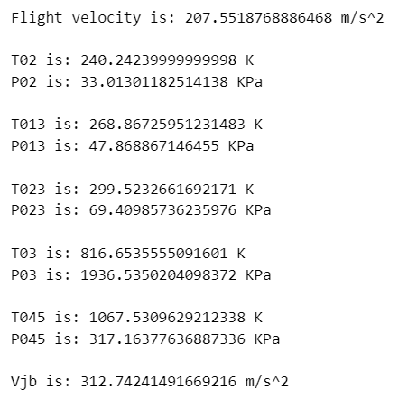
Figure 7 - Results for 4.1
Figure 6 - Code for Table 4.1

- 4.2 – Code
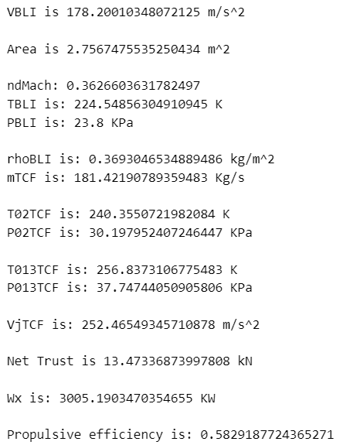
Figure 9 - Results for 4.2
Figure 8 – Code for Table 4.2
- 4.3 – Code
Figure 10 - Code to Plot Efficiency/R2
- 4.5 Code
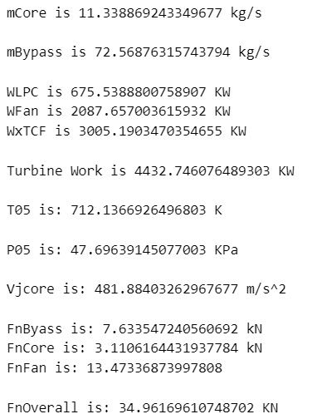
Figure 11 - Results for 4.5
Figure 12 - Code for Table 4.5
Figure 9 - Results for 4.5

